# VIBRATION ANALYSIS OF WING

#### Data of NACA 4412 Airfoil

|  |  |  |
| --- | --- | --- |
| X_axis | Y_upper | Y_lower |
| 1 | 0 | 0 |
| 0.95 | 0.0147 | -0.0016 |
| 0.9 | 0.0271 | -0.0022 |
| 0.8 | 0.0489 | -0.0039 |
| 0.7 | 0.0669 | -0.0065 |
| 0.6 | 0.0814 | -0.01 |
| 0.5 | 0.0919 | -0.014 |
| 0.4 | 0.098 | -0.018 |
| 0.3 | 0.0976 | -0.0226 |
| 0.25 | 0.0941 | -0.025 |
| 0.2 | 0.088 | -0.0274 |
| 0.15 | 0.0789 | -0.0288 |
| 0.1 | 0.0659 | -0.0286 |
| 0.075 | 0.0576 | -0.0274 |
| 0.05 | 0.0473 | -0.0249 |
| 0.025 | 0.0339 | -0.0195 |
| 0.0125 | 0.0244 | -0.0143 |

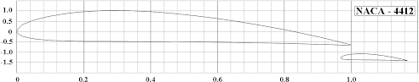

NACA4412

**Numerical Analysis**

**CAD Modelling of Wing**

The solid model of an aircraft wing was made using Ansys. First, The coordinate (X, Y) values of the airfoil were obtained from the UIUC airfoil site and imported to excel. Another column was added for Z-axis and the values were kept zero. That file was saved in the format text document. Later, a curve was drawn in Ansys using the feature “Curve Through XYZ points” using that text file. Then, the curve was converted and the proper dimension of the cord length was given. The extrude boss feature was used to make a 3D model shown in fig. below.

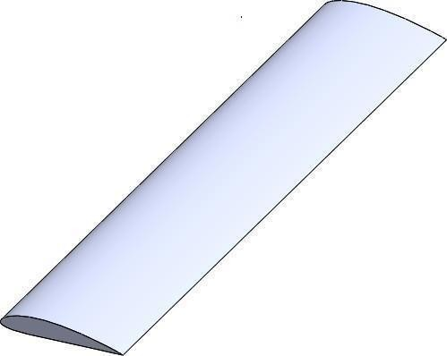

**Fig**: NACA 4412

## Dimensions

Similar to the theoretical analysis, cord length and wing length are taken as 1m and 5m respectively.

## Meshing

The unit cell size of a mesh is very important. The accuracy of the result of the experiment depends on the element size of the mesh. Finer element size enhances the precision of the result, but this requires higher computing power and consumes more time. As the total number of nodes increases with the increase of the total number of element size, the simulation requires solving all those points. Keeping the computing power of the computer used, the mesh was generated shown in fig. Solid 187 was used as an element. The number of elements was 45332 and the number of nodes was 81494.

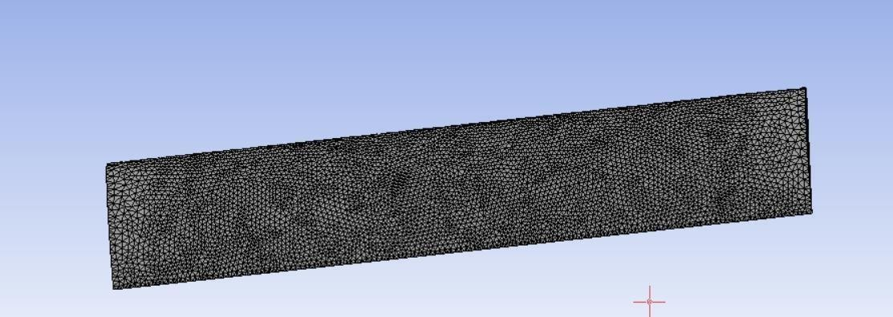

**Fig:** Zoom view of mesh element

## Boundary Conditions

At the Root of the wing, frictionless fixed support was given similar to a cantilever beam. Frictionless support places a normal constraint on the entire surface.

## Material

The material selected for this study was Aluminum Alloy 6061

Material properties of Aluminum Alloy 6061

|  |  |
| --- | --- |
| **Properties** | **Values** |
| Young's Modulus | 69 GPa |
| Poisson's Ratio | 0.33 |
| Tensile Strength: Ultimate (UTS) | 310 MPa |
| Thermal Conductivity | 167 W/m-K |
| Density | 2700 kg/m3 |
|  |  |

**OUR MODEL STUDY CONFIGURATION**

In this fig. our course of study wing has 5 m span with 1cm thickness of skin. Its having chord of 1m. Here , we use I-shaped single spar .We may use C- shaped as well. Through this wing we are trying to study affect on natural frequency and deformation we get with different spacing placement of ribs. With spar keeping it fixed at c/4 we use 4 ribs of thickness 10cm each and relocate at different positions. In case 1, we use linear spacing between ribs of distance 1.53 m . In case 2, we use GP of common ratio 1.229. In case 3, we use golden ratio. In case 4, we use Fibonacci .

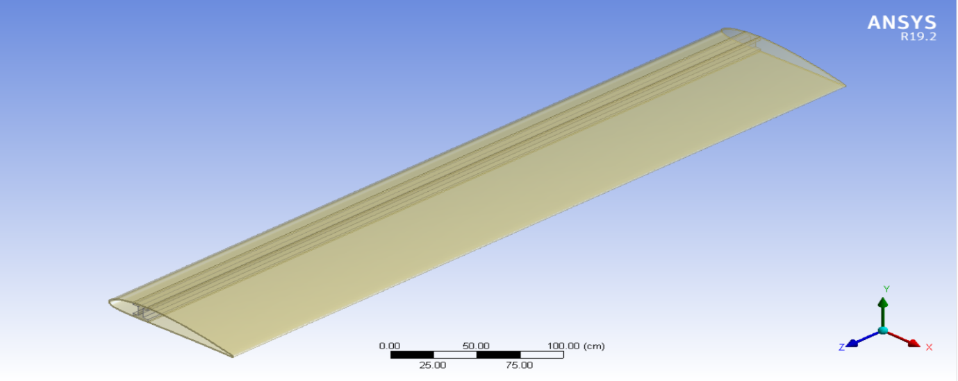

LINEAR CONFIGURATION:

Here we have considered distance between two ribs constant

D1=D2=D3=(500-40)/3=153.33cm

GEOMETRIC PROGRESSION:

In this case we have considered the distance between ribs increasing by a factor of r

r+r^2+r^3=500cm-40cm

From here

D1=122.9cm

D2=151.04cm

D3=185.63cm

GOLDEN RATIO:

In this case we have considered common ratio 1.6

x+1.6x+1.6*1.6*x=500cm-40cm

From here we got

D1=89.84cm

D2=143.74cm

D3=229.99cm

FIBONACCI:

D1=x

D2=x

D3=2x

So we have

X =460/4=115cm

From here we got-D1=115cm;D2=115cm;D3=230cm

**Different Ribs Spacing**

1.Linear

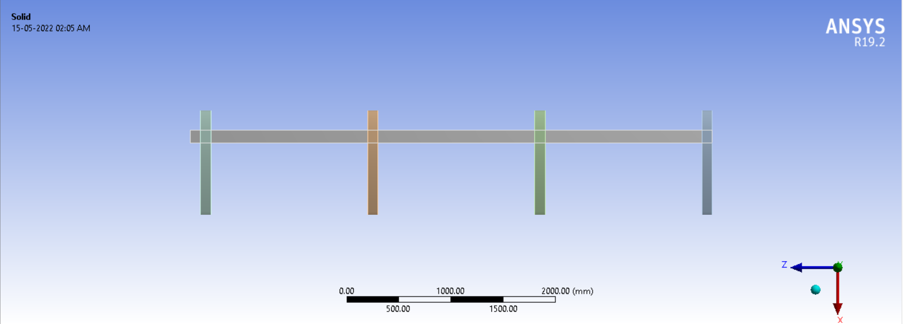

Deformation 1

Figure 3 represents the total deformation of the wing structure at the first nodal displacement,

in which at one end the deformation is maximum highlighted in red color and the blue color

denotes the minimum deformation occurs due to frequency of the aircraft wing while flying in

sky.

Figure 3 represents the total deformation of the wing structure at the first nodal displacement,

in which at one end the deformation is maximum highlighted in red color and the blue color

denotes the minimum deformation occurs due to frequency of the aircraft wing while flying in

sky.

Figure 3 represents the total deformation of the wing structure at the first nodal displacement,

in which at one end the deformation is maximum highlighted in red color and the blue color

denotes the minimum deformation occurs due to frequency of the aircraft wing while flying in

sky.

Fig. shown here represents the total displacement of the wing structure at the first nodal displacement, in which at one ends the deformation is maximum highlighted in red colour and the blue colour denotes the minimum deformation occurs due to frequency of the aircraft wing while flying in the sky.

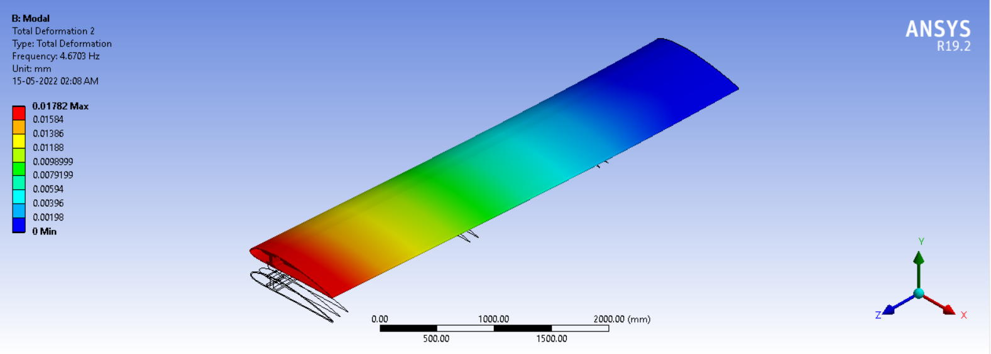

Deformation 2

Fig. shown here represents the total displacement of the wing structure at the second nodal displacement, in which at one ends the deformation is maximum highlighted in red colour and the blue colour denotes the minimum deformation occurs due to frequency of the aircraft wing while flying in the sky.

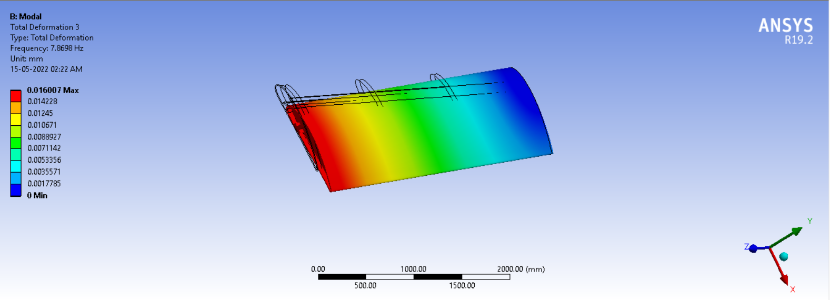

Deformation 3

Fig. shown here represents the total displacement of the wing structure at the third nodal displacement, in which at the end the deformation is maximum highlighted in red colour and the blue colour denotes the minimum deformation occurs due to frequency of the aircraft wing while flying in the sky.

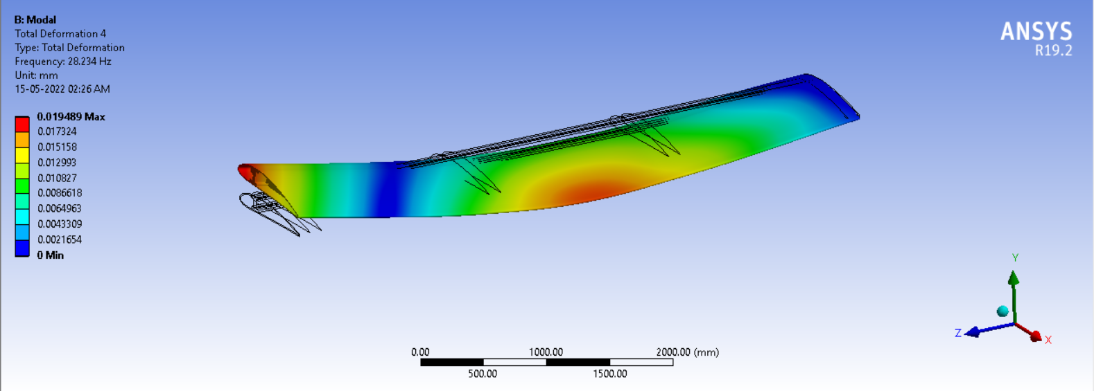

Deformation 4

Fig. shown here represents the total displacement of the wing structure at the fourth nodal displacement, and it depicts torsional vibration. The end the deformation is maximum highlighted in red colour and the blue colour denotes the minimum deformation occurs due to frequency of the aircraft wing while flying in the sky.

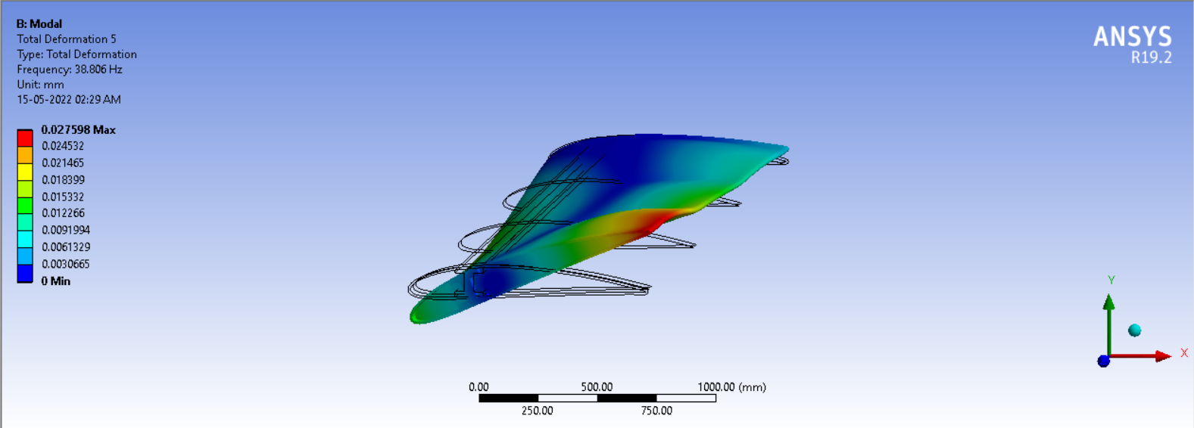

Deformation 5

Fig. shown here represents the total displacement of the wing structure at the fifth nodal displacement. The end the deformation is maximum highlighted in red colour and the blue colour denotes the minimum deformation occurs due to frequency of the aircraft wing while flying in the sky.

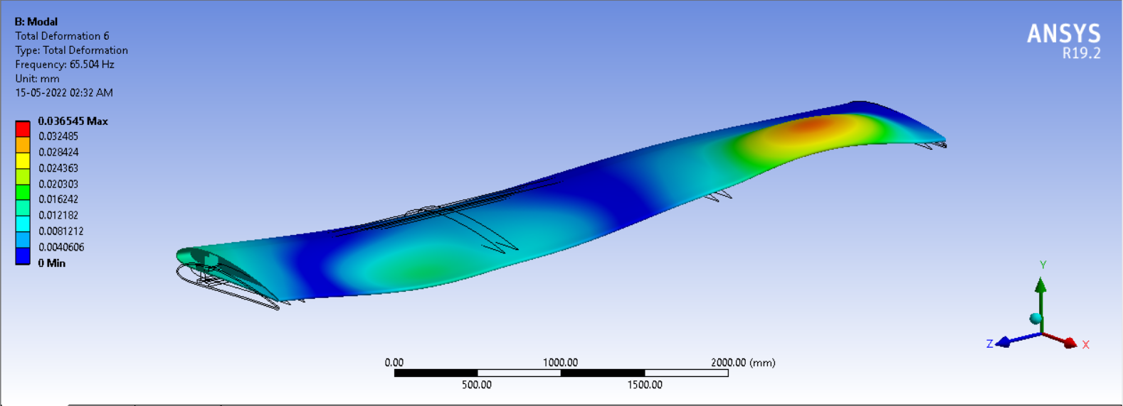

Deformation 6

Fig. shown here represents the total displacement of the wing structure at the sixth nodal displacement. The end the deformation is maximum highlighted in red colour and the blue colour denotes the minimum deformation occurs due to frequency of the aircraft wing while flying in the sky.

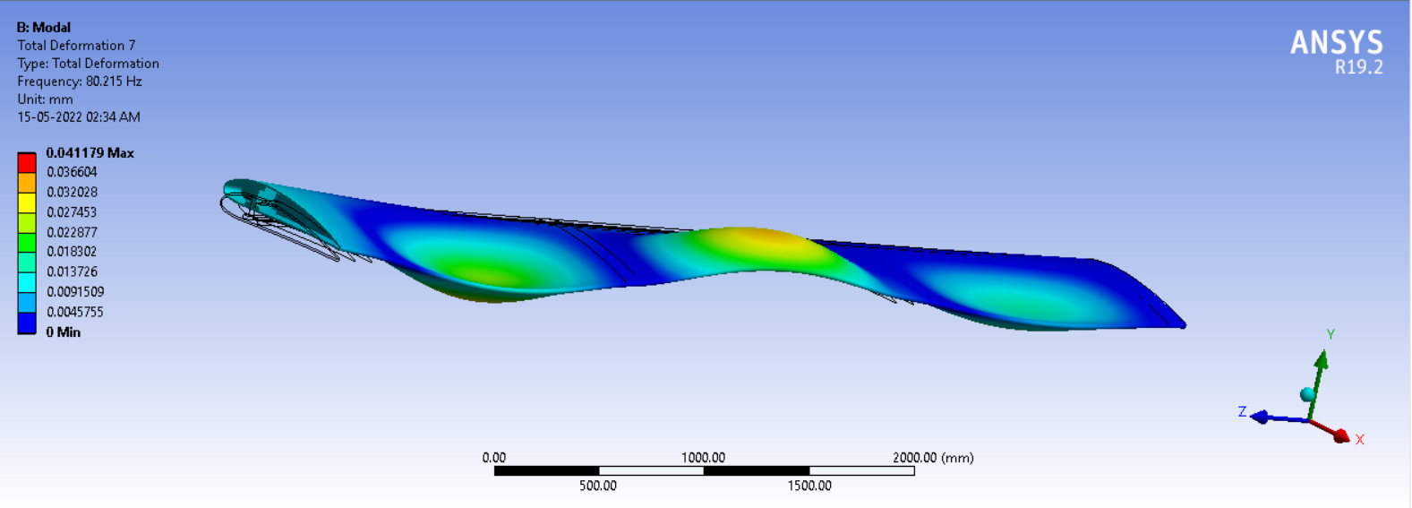

Total deformation of the wing structure according to its nodal displacement as shown in the table.

|  |  |  |  |
| --- | --- | --- | --- |
| Mode | Max. Deformation | Min. Deformation | Frequency(Hz) |
| 1 | 0.01782 | 0.0 | 4.6703 |
| 2 | 0.016007 | 0.0 | 7.8698 |
| 3 | 0.019489 | 0.0 | 28.234 |
| 4 | 0.027598 | 0.0 | 38.806 |
| 5 | 0.036545 | 0.0 | 65.504 |
| 6 | 0.041179 | 0.0 | 80.215 |

2. Geometric Proportion

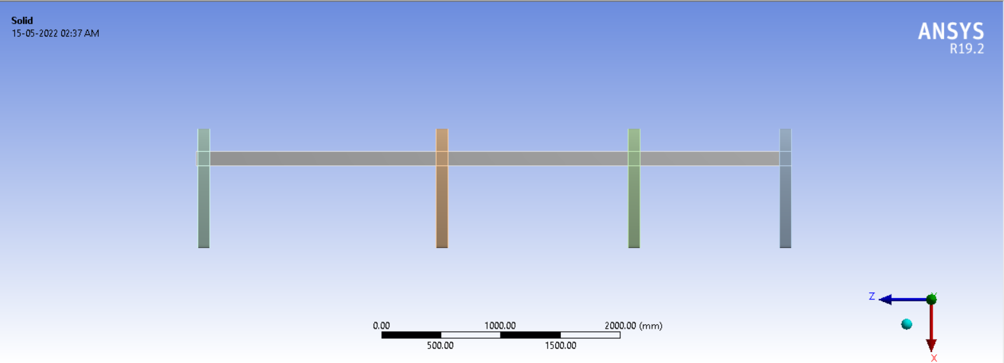

Deformation 1

Figure 3 represents the total deformation of the wing structure at the first nodal displacement,

in which at one end the deformation is maximum highlighted in red color and the blue color

denotes the minimum deformation occurs due to frequency of the aircraft wing while flying in

sky.

Figure 3 represents the total deformation of the wing structure at the first nodal displacement,

in which at one end the deformation is maximum highlighted in red color and the blue color

denotes the minimum deformation occurs due to frequency of the aircraft wing while flying in

sky.

Figure 3 represents the total deformation of the wing structure at the first nodal displacement,

in which at one end the deformation is maximum highlighted in red color and the blue color

denotes the minimum deformation occurs due to frequency of the aircraft wing while flying in

sky.

Fig. shown here represents the total displacement of the wing structure at the first nodal displacement, in which at one ends the deformation is maximum highlighted in red colour and the blue colour denotes the minimum deformation occurs due to frequency of the aircraft wing while flying in the sky.

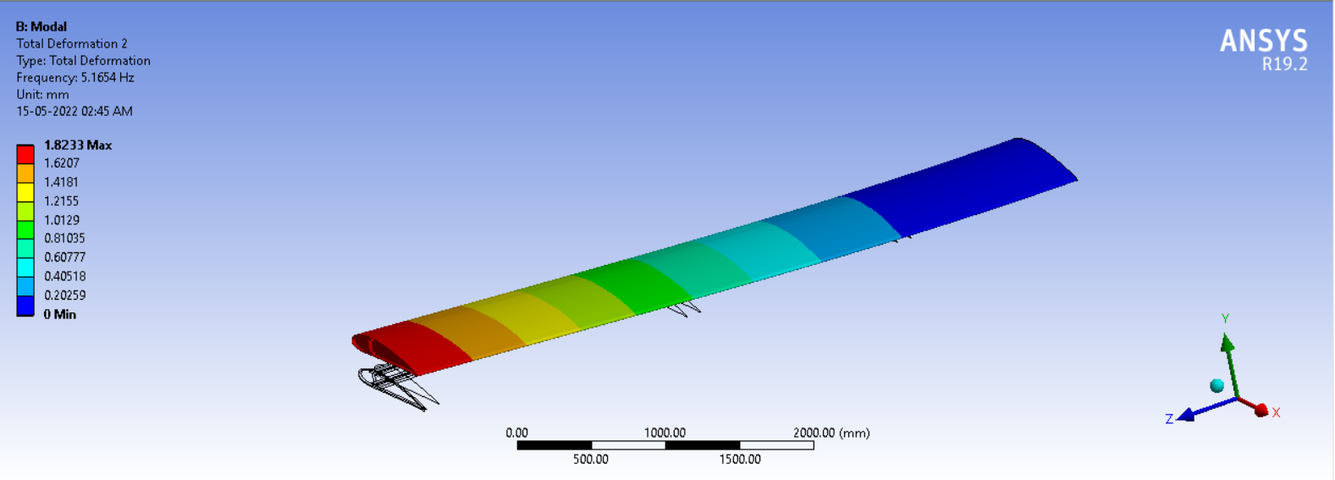

Deformation 2

Fig. shown here represents the total displacement of the wing structure at the second nodal displacement, in which at one ends the deformation is maximum highlighted in red colour and the blue colour denotes the minimum deformation occurs due to frequency of the aircraft wing while flying in the sky.

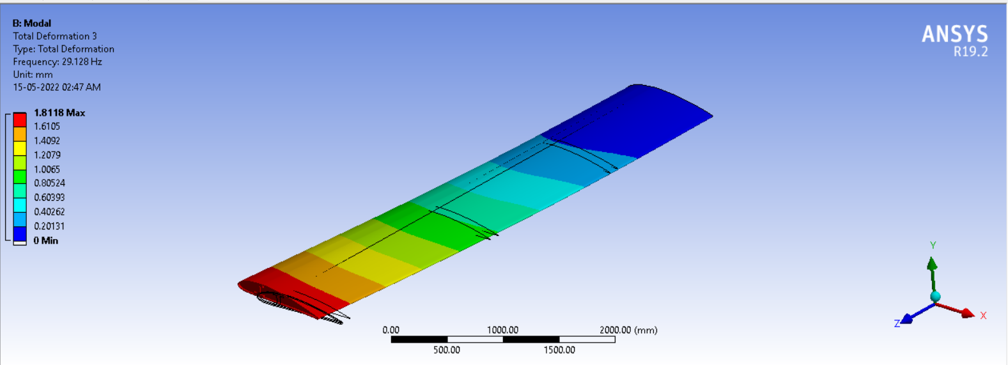

Deformation 3

Fig. shown here represents the total displacement of the wing structure at the third nodal displacement, in which at the end the deformation is maximum highlighted in red colour and the blue colour denotes the minimum deformation occurs due to frequency of the aircraft wing while flying in the sky

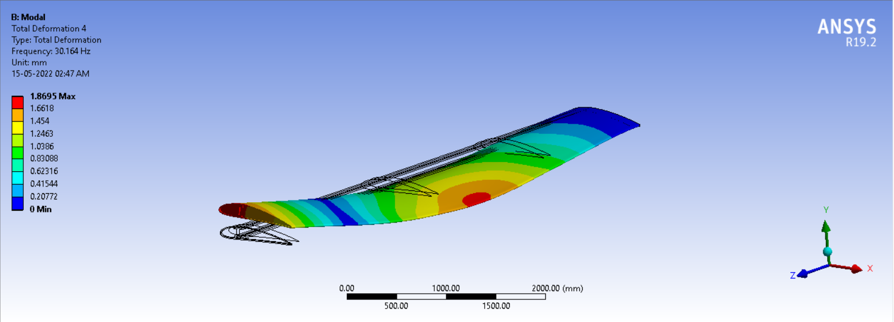

Deformation 4

Fig. shown here represents the total displacement of the wing structure at the fourth nodal displacement, and it depicts torsional vibration. The end the deformation is maximum highlighted in red colour and the blue colour denotes the minimum deformation occurs due to frequency of the aircraft wing while flying in the sky.

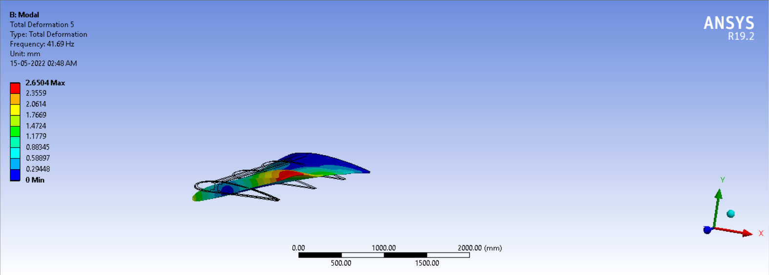

Deformation 5

Fig. shown here represents the total displacement of the wing structure at the fifth nodal displacement. The end the deformation is maximum highlighted in red colour and the blue colour denotes the minimum deformation occurs due to frequency of the aircraft wing while flying in the sky.

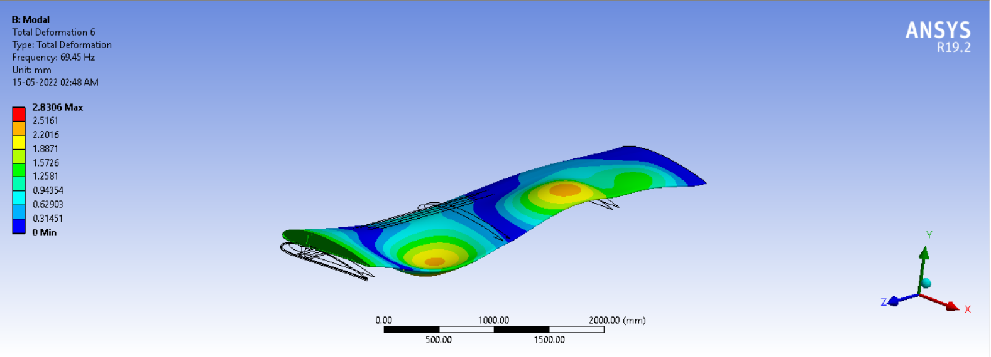

Deformation 6

Fig. shown here represents the total displacement of the wing structure at the sixth nodal displacement. The end the deformation is maximum highlighted in red colour and the blue colour denotes the minimum deformation occurs due to frequency of the aircraft wing while flying in the sky.

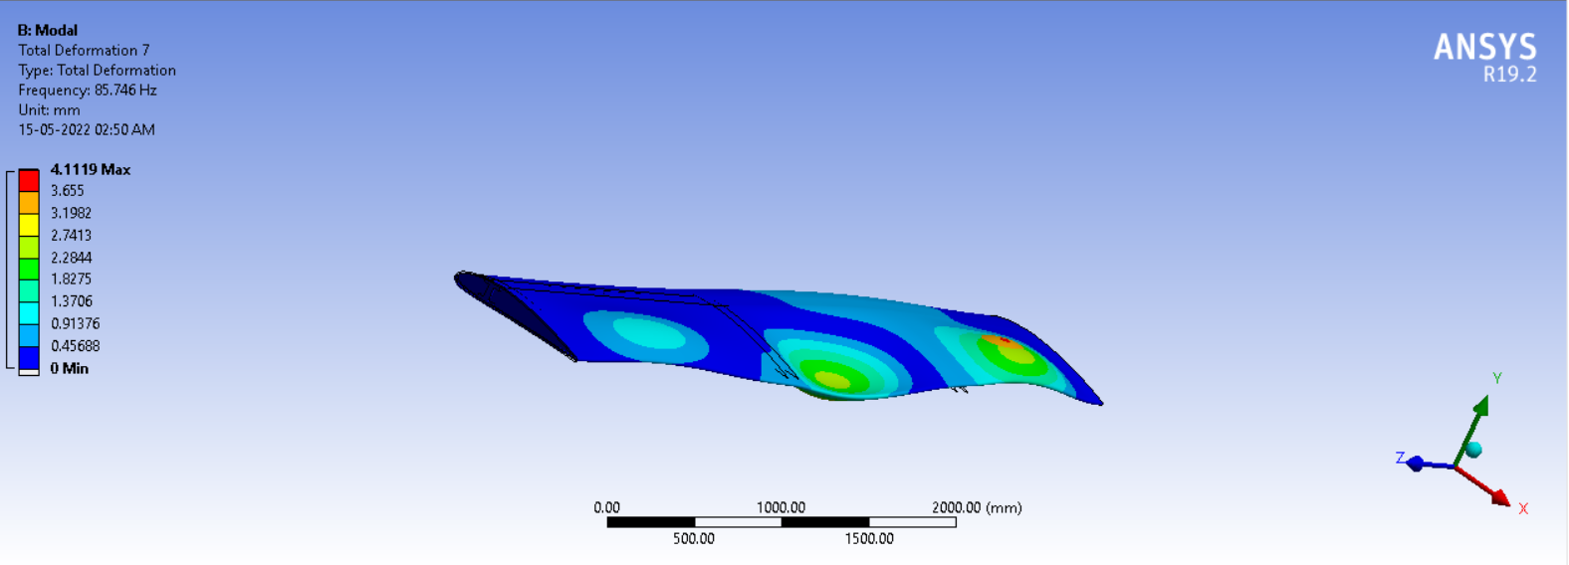

|  |  |  |  |
| --- | --- | --- | --- |
| Mode | Max. Deformation | Min. Deformation | Frequency(Hz) |
| 1 | 1.8233 | 0.0 | 5.1654 |
| 2 | 1.8118 | 0.0 | 29.128 |
| 3 | 1.8695 | 0.0 | 30.164 |
| 4 | 2.6504 | 0.0 | 41.69 |
| 5 | 2.8306 | 0.0 | 69.45 |
| 6 | 4.1119 | 0.0 | 85.746 |

3. Golden Ratio

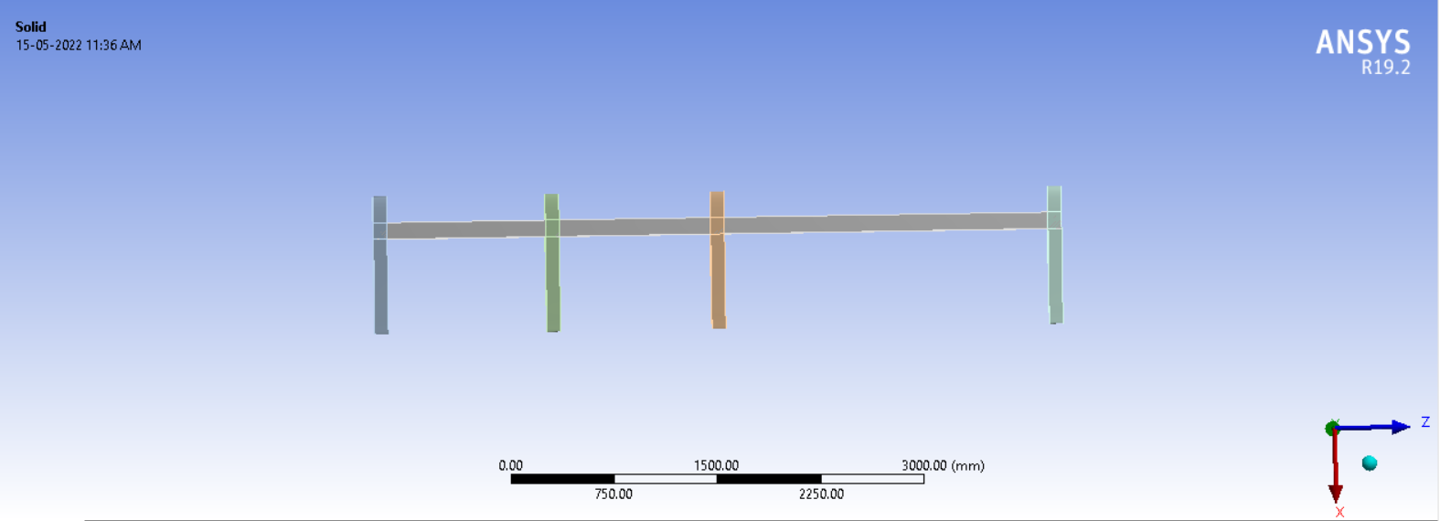

Deformation 1

Figure 3 represents the total deformation of the wing structure at the first nodal displacement,

in which at one end the deformation is maximum highlighted in red color and the blue color

denotes the minimum deformation occurs due to frequency of the aircraft wing while flying in

sky.

Figure 3 represents the total deformation of the wing structure at the first nodal displacement,

in which at one end the deformation is maximum highlighted in red color and the blue color

denotes the minimum deformation occurs due to frequency of the aircraft wing while flying in

sky.

Figure 3 represents the total deformation of the wing structure at the first nodal displacement,

in which at one end the deformation is maximum highlighted in red color and the blue color

denotes the minimum deformation occurs due to frequency of the aircraft wing while flying in

sky.

Fig. shown here represents the total displacement of the wing structure at the first nodal displacement, in which at one ends the deformation is maximum highlighted in red colour and the blue colour denotes the minimum deformation occurs due to frequency of the aircraft wing while flying in the sky.

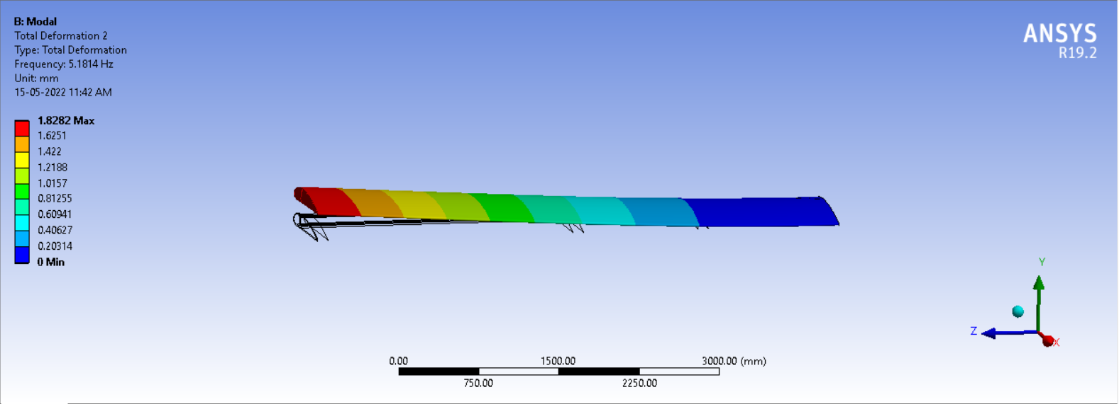

Deformation 2

Fig. shown here represents the total displacement of the wing structure at the second nodal displacement, in which at one ends the deformation is maximum highlighted in red colour and the blue colour denotes the minimum deformation occurs due to frequency of the aircraft wing while flying in the sky.

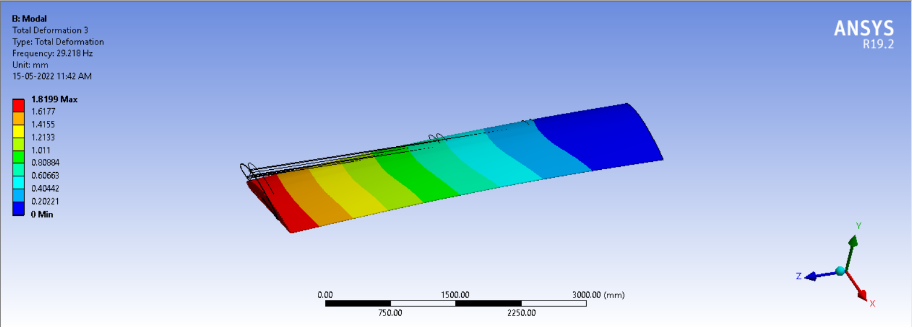

Deformation 3

Fig. shown here represents the total displacement of the wing structure at the third nodal displacement, in which at the end the deformation is maximum highlighted in red colour and the blue colour denotes the minimum deformation occurs due to frequency of the aircraft wing while flying in the sky

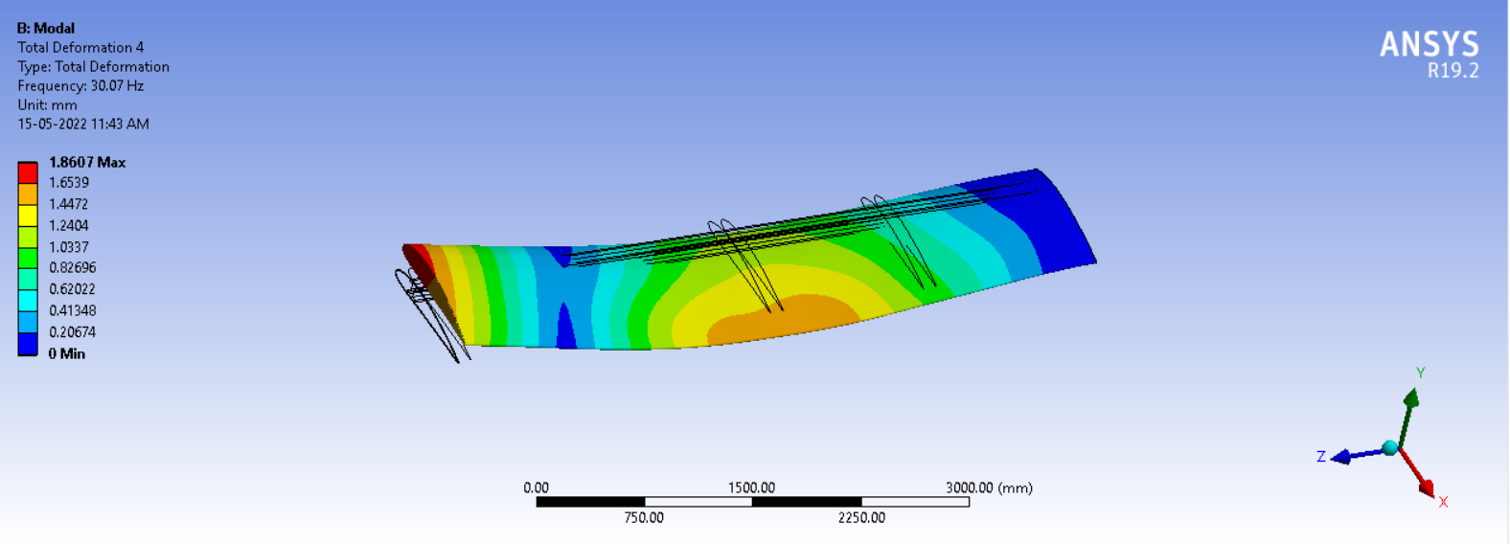

Deformation 4

Fig. shown here represents the total displacement of the wing structure at the fourth nodal displacement, and it depicts torsional vibration. The end the deformation is maximum highlighted in red colour and the blue colour denotes the minimum deformation occurs due to frequency of the aircraft wing while flying in the sky.

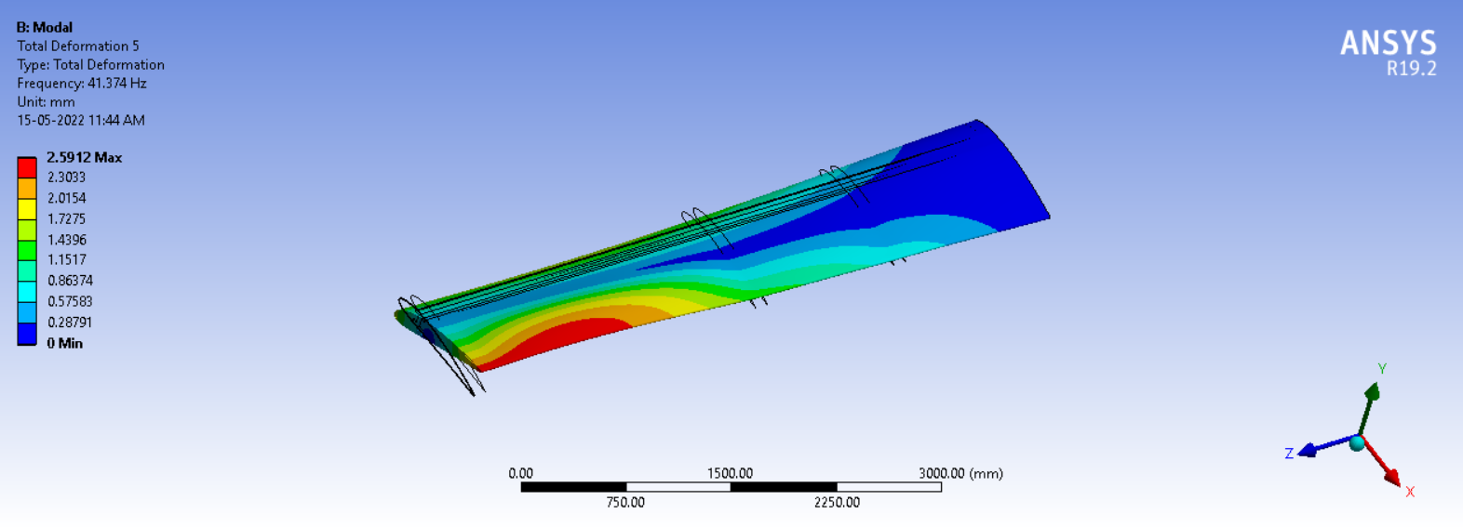

Deformation 5

Fig. shown here represents the total displacement of the wing structure at the fifth nodal displacement. The end the deformation is maximum highlighted in red colour and the blue colour denotes the minimum deformation occurs due to frequency of the aircraft wing while flying in the sky.

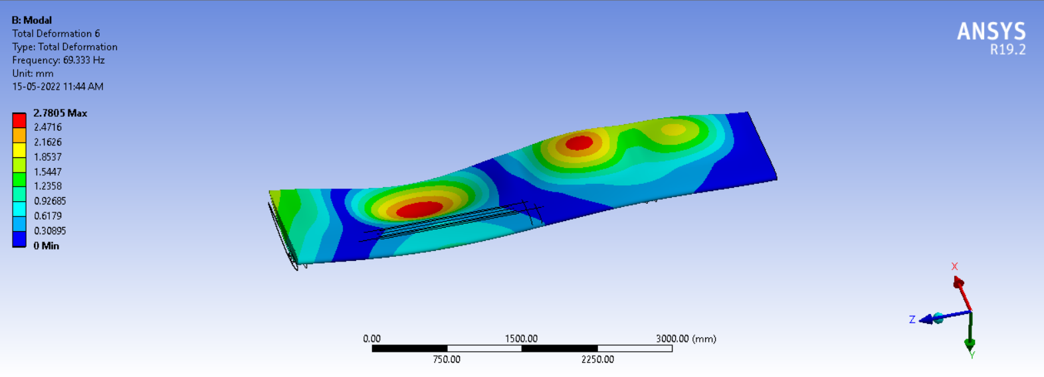

Deformation 6

Fig. shown here represents the total displacement of the wing structure at the sixth nodal displacement. The end the deformation is maximum highlighted in red colour and the blue colour denotes the minimum deformation occurs due to frequency of the aircraft wing while flying in the sky.

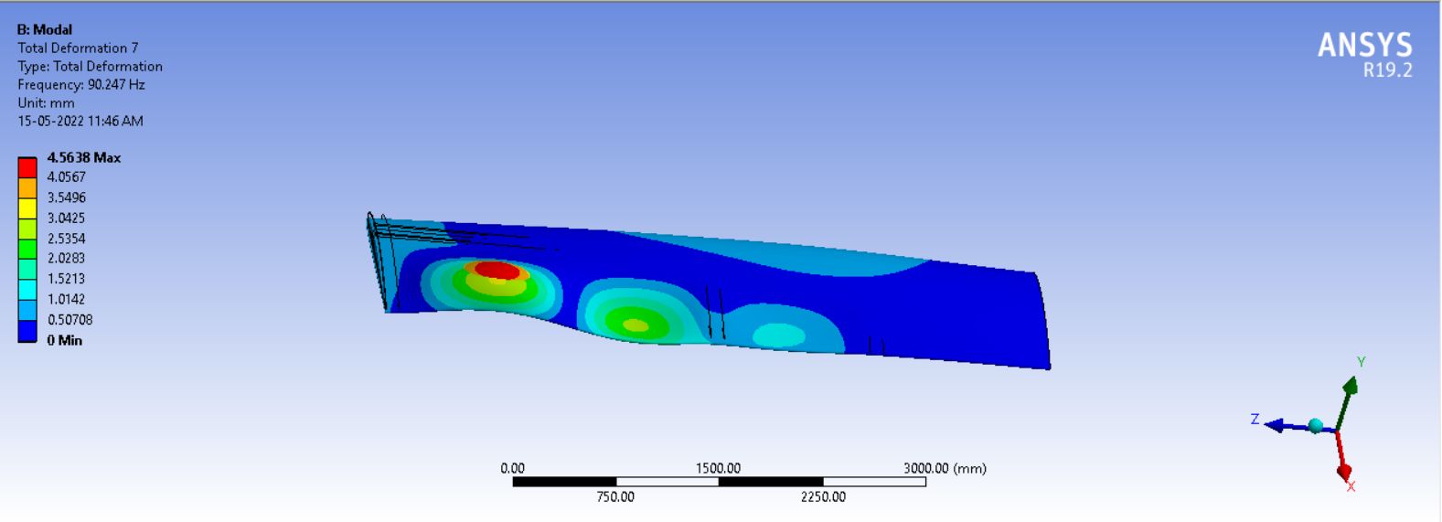

Total deformation of the wing structure according to its nodal displacement as shown in the table.

|  |  |  |  |
| --- | --- | --- | --- |
| Mode | Max. Deformation | Min. Deformation | Frequency(Hz) |
| 1 | 1.8228 | 0.0 | 5.1814 |
| 2 | 1.8199 | 0.0 | 29.218 |
| 3 | 1.8607 | 0.0 | 30.07 |
| 4 | 2.5912 | 0.0 | 41.374 |
| 5 | 2.7805 | 0.0 | 69.333 |
| 6 | 4.5638 | 0.0 | 90.247 |

4. Fibonacci

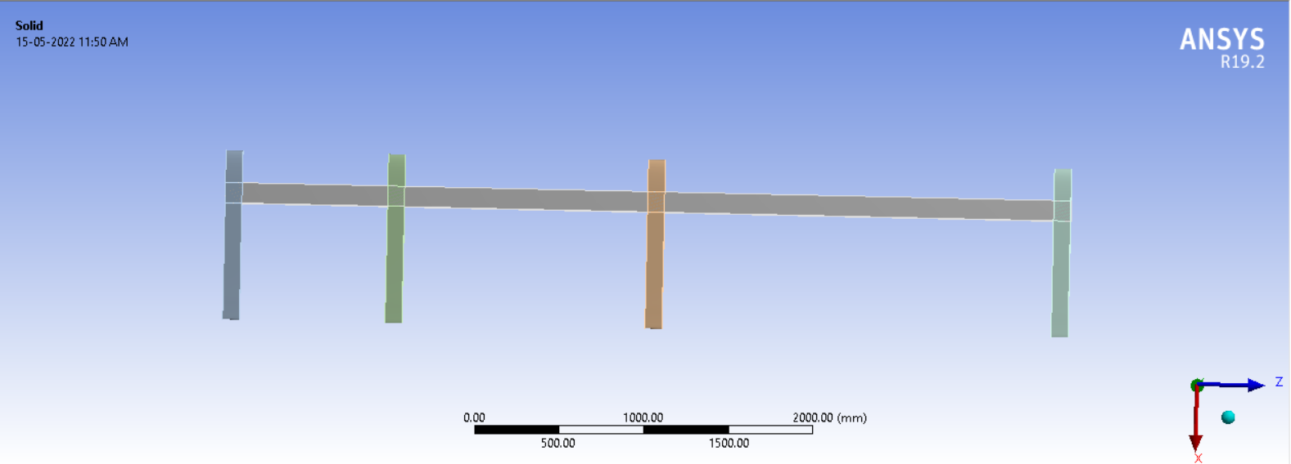

Deformation 1

Figure 3 represents the total deformation of the wing structure at the first nodal displacement,

in which at one end the deformation is maximum highlighted in red color and the blue color

denotes the minimum deformation occurs due to frequency of the aircraft wing while flying in

sky.

Figure 3 represents the total deformation of the wing structure at the first nodal displacement,

in which at one end the deformation is maximum highlighted in red color and the blue color

denotes the minimum deformation occurs due to frequency of the aircraft wing while flying in

sky.

Figure 3 represents the total deformation of the wing structure at the first nodal displacement,

in which at one end the deformation is maximum highlighted in red color and the blue color

denotes the minimum deformation occurs due to frequency of the aircraft wing while flying in

sky.

Fig. shown here represents the total displacement of the wing structure at the first nodal displacement, in which at one ends the deformation is maximum highlighted in red colour and the blue colour denotes the minimum deformation occurs due to frequency of the aircraft wing while flying in the sky.

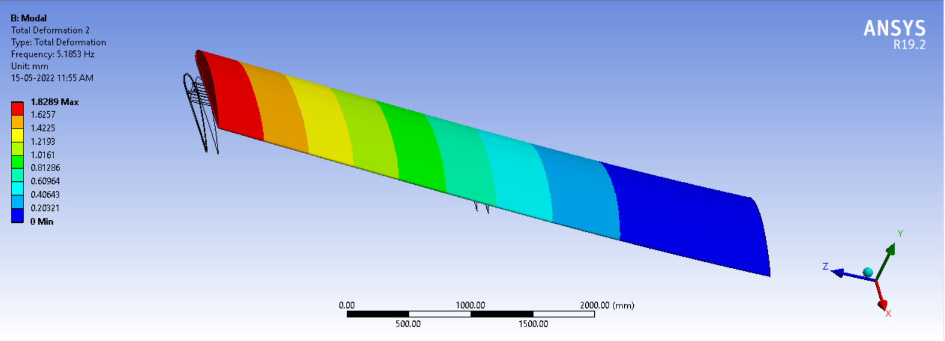

Deformation 2

Fig. shown here represents the total displacement of the wing structure at the second nodal displacement, in which at one ends the deformation is maximum highlighted in red colour and the blue colour denotes the minimum deformation occurs due to frequency of the aircraft wing while flying in the sky.

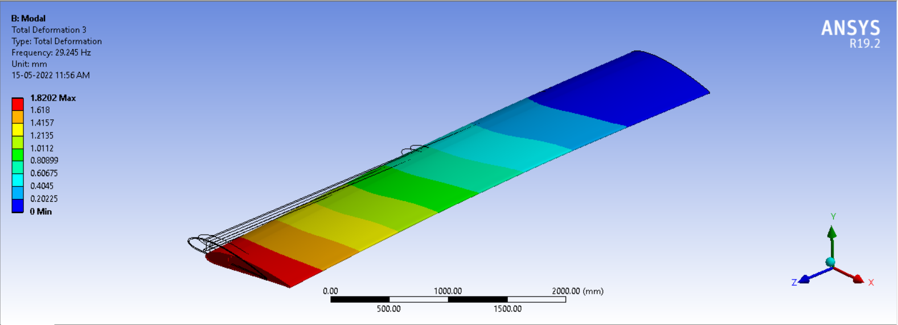

Deformation 3

Fig. shown here represents the total displacement of the wing structure at the third nodal displacement, in which at the end the deformation is maximum highlighted in red colour and the blue colour denotes the minimum deformation occurs due to frequency of the aircraft wing while flying in the sky

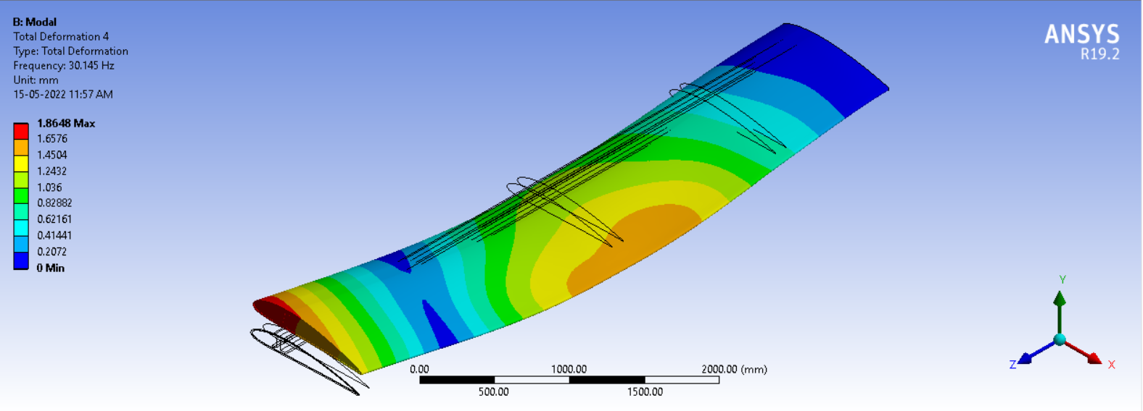

Deformation 4

Fig. shown here represents the total displacement of the wing structure at the fourth nodal displacement, and it depicts torsional vibration. The end the deformation is maximum highlighted in red colour and the blue colour denotes the minimum deformation occurs due to frequency of the aircraft wing while flying in the sky.

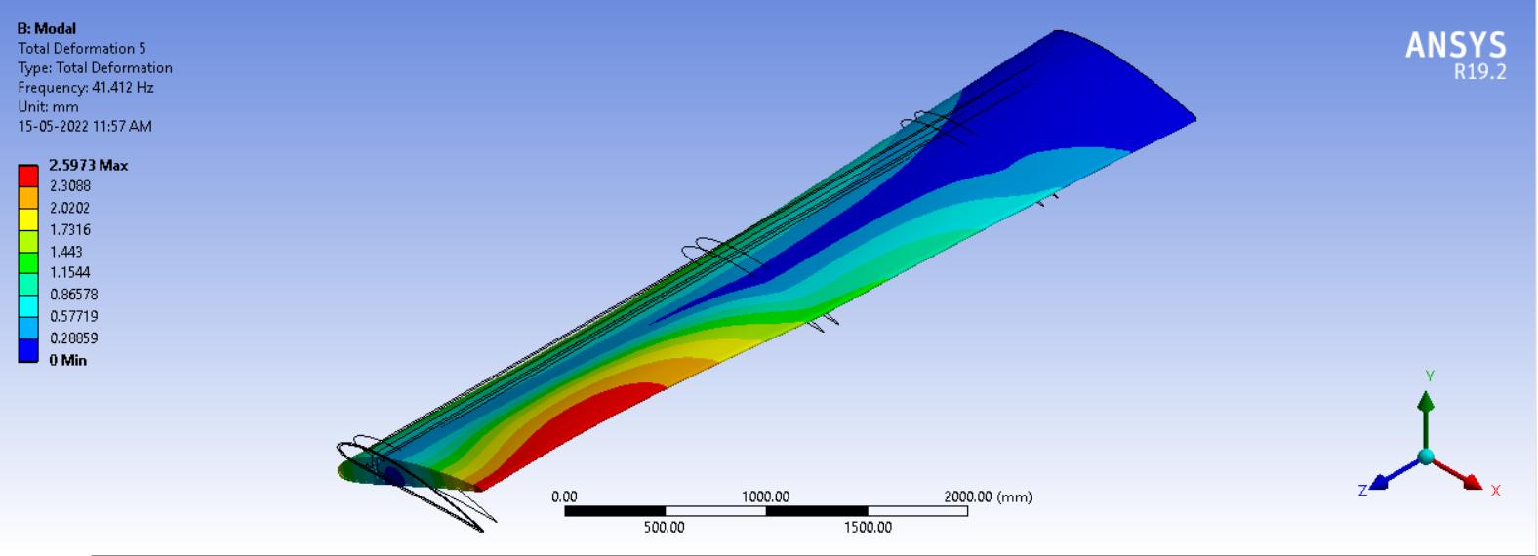

Deformation 5

Fig. shown here represents the total displacement of the wing structure at the fifth nodal displacement. The end the deformation is maximum highlighted in red colour and the blue colour denotes the minimum deformation occurs due to frequency of the aircraft wing while flying in the sky.

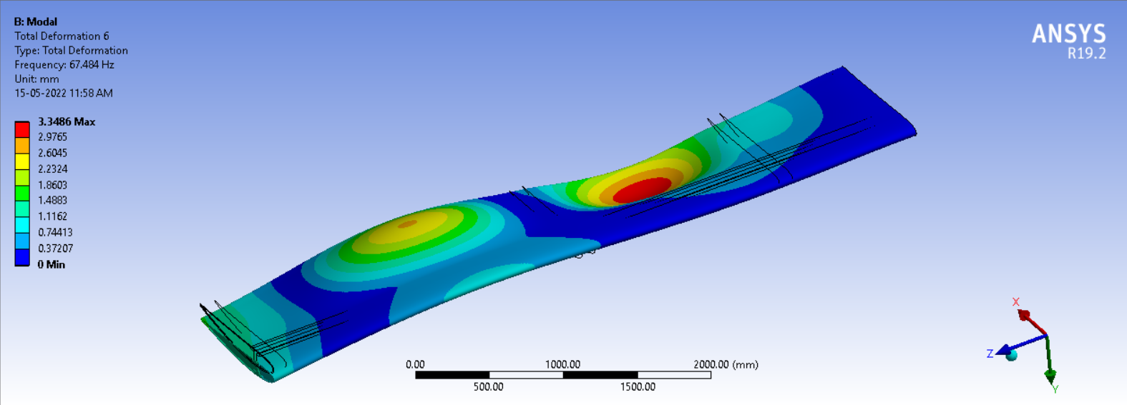

Deformation 6

Fig. shown here represents the total displacement of the wing structure at the sixth nodal displacement. The end the deformation is maximum highlighted in red colour and the blue colour denotes the minimum deformation occurs due to frequency of the aircraft wing while flying in the sky.

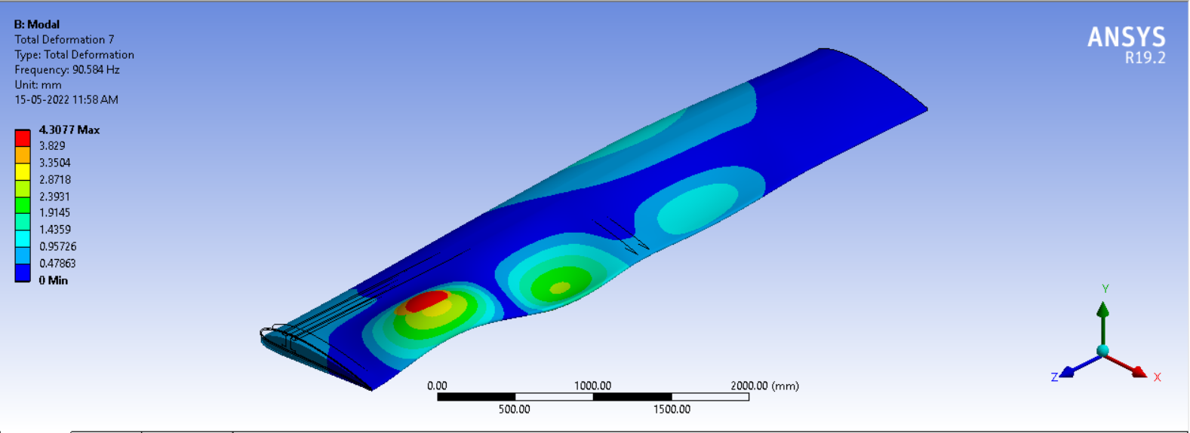

Total deformation of the wing structure according to its nodal displacement as shown in the table.

|  |  |  |  |
| --- | --- | --- | --- |
| Mode | Max. Deformation | Min. Deformation | Frequency(Hz) |
| 1 | 1.8289 | 0.0 | 5.1853 |
| 2 | 1.8202 | 0.0 | 29.245 |
| 3 | 1.8648 | 0.0 | 30.145 |
| 4 | 2.5973 | 0.0 | 41.412 |
| 5 | 3.3486 | 0.0 | 67.484 |
| 6 | 4.3077 | 0.0 | 90.584 |

**Comparison of Results of deformation**

In this graph, the first line shows clear exponential curve type shape .This is the case of our study on beam .Else are frequency of different cases on wings. We find here all the cases nearly same natural frequency with case i.e. linear spacing one least frequency.

In the graph , different curves depicting different cases of ribs placing discussed above.

In this graph, blue one depicting the linear case while all other are g.p. , golden ratio and fibonacci cases.